As we have seen throughout the different periods covered thus far in our study of women’s history, wartime is often a period of chaos and disarray, as well as a time when we see women’s roles change. World War II is another moment in U.S. history which disrupts the normal lives of so many Americans and propels women into non-combat military roles and heavy manufacturing jobs, all in support of the war effort and to meet the needs of industry to produce for the same.
Norman Rockwell’s 1943 painting and Saturday Evening Post cover from May 29, 1943 has become an iconic symbol of these Rosie the Riveters, women who put on overalls to get the often-times dirty job done. (While the “We Can Do It!” poster is more highly recognized today and from the same year, it was not widely known at the time. The Rockwell image on the other hand was the cover of the Saturday Evening Post, the most widely circulated and influential weekly magazine at the time. You can read more about Rockwell’s “Rosie the Riveter” here (Links to an external site.).)

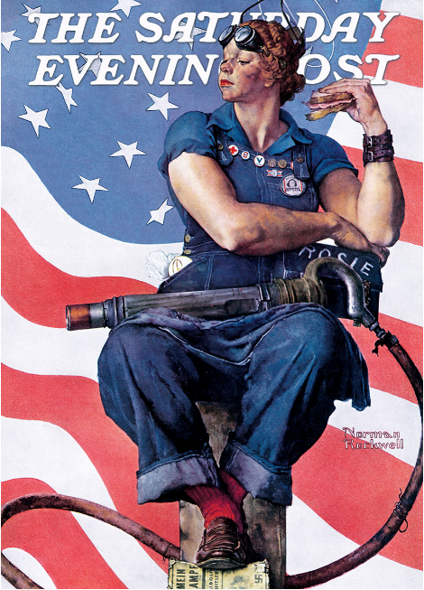
Based on the images of Rosie the Riveter and the propaganda posters found on pages 509 and 542 (5th ed.), you will write a 4-page essay (in addition to a cover page and Bibliography page) that compares these images and the messages they convey with two other examples of women’s experiences working during WWII, found in the textbook (pages 542-544). You will compare the experiences presented in each woman's story as well as compare these real-life experiences to the propaganda posters of women’s work and the women at work they convey. The essay should address the following questions:
- What is the historical context of each of these sources? (Who, what, when, where of the sources)
- How do the two interview sources describe their work during the war – what did they do and how did they feel about doing it?
- What message(s) do the images send, to the U.S. public, as well as to women specifically, about women’s labor during WWII?
- What are the consistencies (what are the shared attributes) of each and how do they differ?
To get started, you will create a thesis statement and outline to be submitted prior to the actual essay. Your draft thesis statement (meaning you can and should continue to edit it after submission) should conform to the standards discussed in the UNC Chapel Hill handout. Be sure to ask yourself the questions posed on this handout to help you draft a strong thesis statement.

